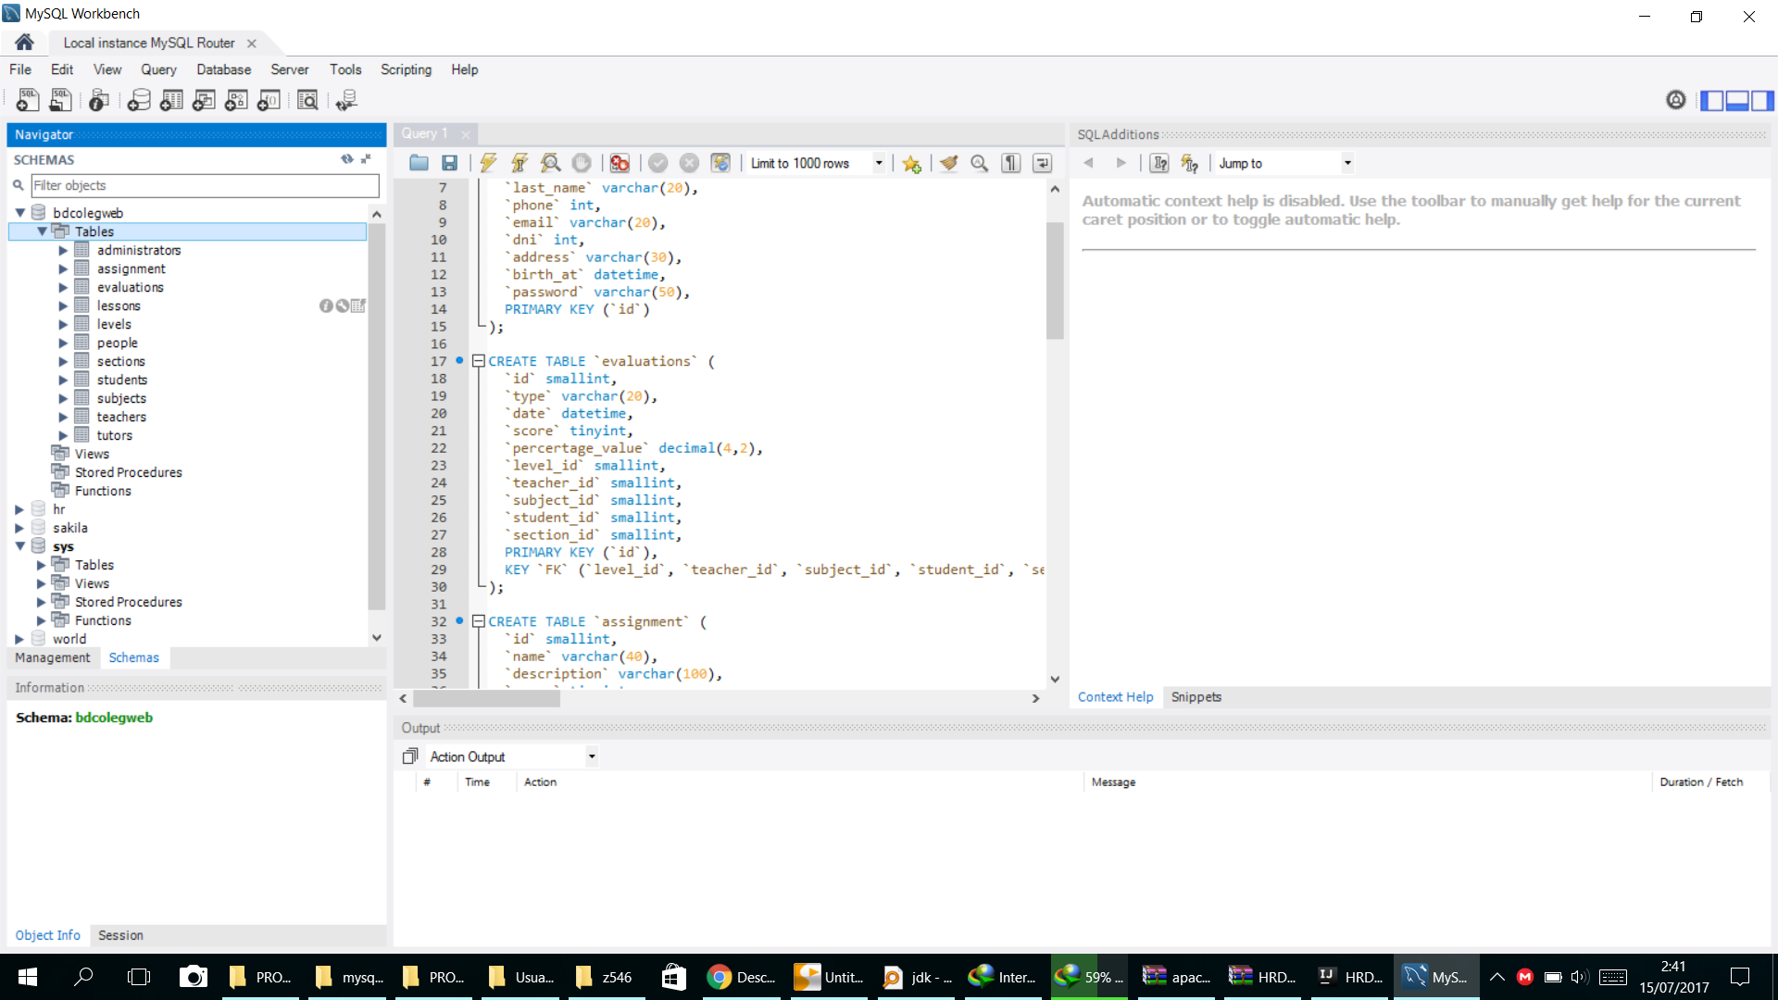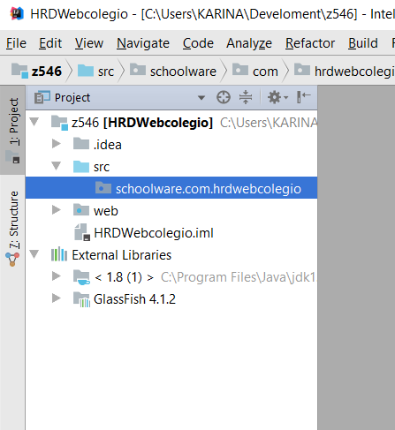

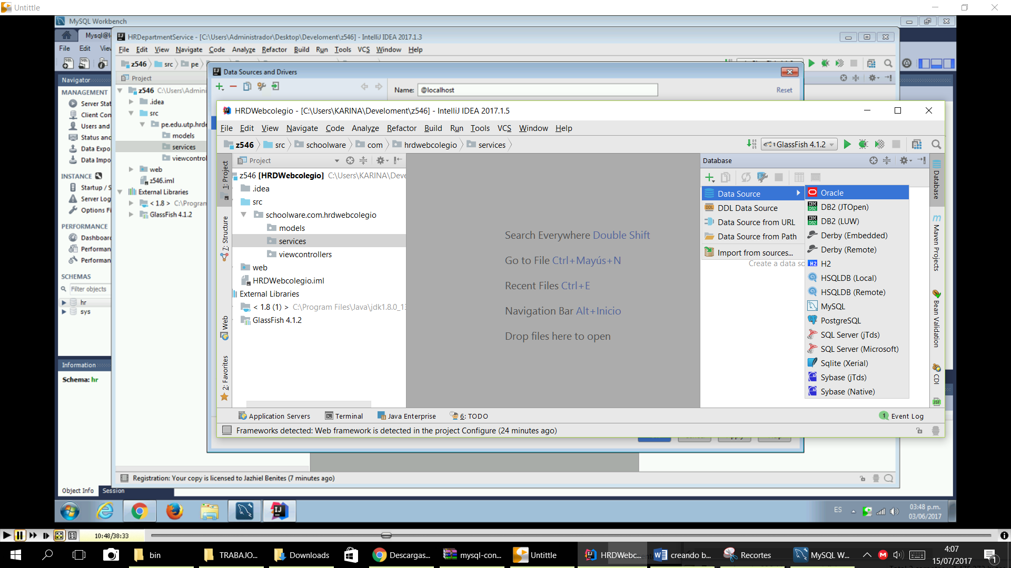

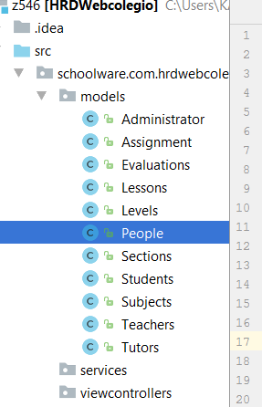

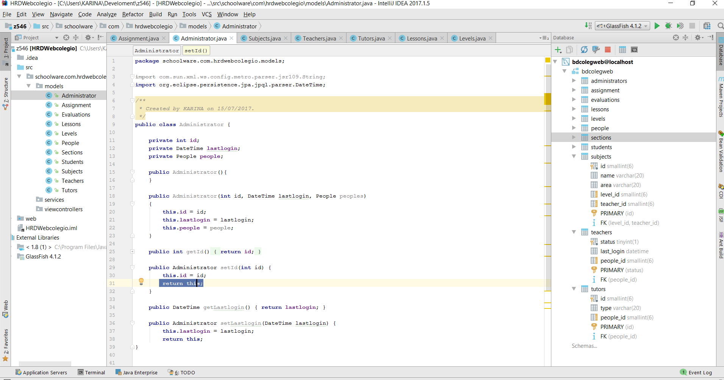

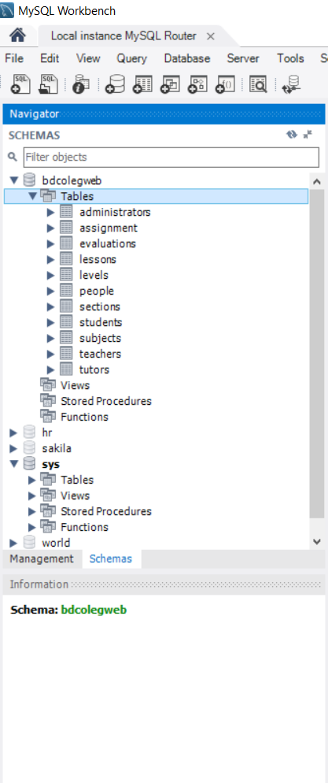

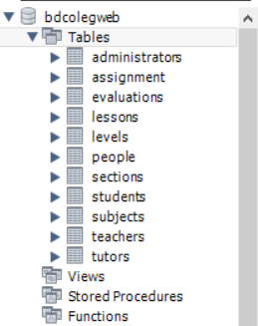

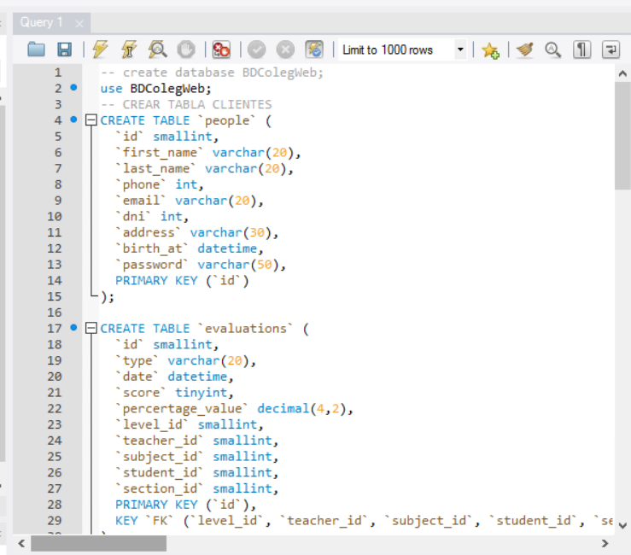

-- create database BDColegWeb;

use BDColegWeb;

-- CREAR TABLA CLIENTES

CREATE TABLE `people` (

`id` smallint,

`first_name` varchar(20),

`last_name` varchar(20),

`phone` int,

`email` varchar(20),

`dni` int,

`address` varchar(30),

`birth_at` datetime,

`password` varchar(50),

PRIMARY KEY (`id`)

);

CREATE TABLE `evaluations` (

`id` smallint,

`type` varchar(20),

`date` datetime,

`score` tinyint,

`percertage_value` decimal(4,2),

`level_id` smallint,

`teacher_id` smallint,

`subject_id` smallint,

`student_id` smallint,

`section_id` smallint,

PRIMARY KEY (`id`),

KEY `FK` (`level_id`, `teacher_id`, `subject_id`, `student_id`, `section_id`)

);

CREATE TABLE `assignment` (

`id` smallint,

`name` varchar(40),

`description` varchar(100),

`score` tinyint,

`subject_id` smallint,

PRIMARY KEY (`id`),

KEY `FK` (`subject_id`)

);

CREATE TABLE `levels` (

`id` smallint,

`name` varchar(20),

`grade` tinyint,

`section_id` smallint,

PRIMARY KEY (`id`),

KEY `FK` (`section_id`)

);

CREATE TABLE `subjects` (

`id` smallint,

`name` varchar(20),

`area` varchar(20),

`level_id` smallint,

`teacher_id` smallint,

PRIMARY KEY (`id`),

KEY `FK` (`level_id`, `teacher_id`)

);

CREATE TABLE `students` (

`id` smallint,

`status` boolean,

`people_id` smallint,

`tutor_id` smallint,

`level_id` smallint,

`subject_id` smallint,

PRIMARY KEY (`id`),

KEY `FK` (`people_id`, `tutor_id`, `level_id`, `subject_id`)

);

CREATE TABLE `administrators` (

`id` smallint,

`last_login` datetime,

`people_id` smallint,

PRIMARY KEY (`id`),

KEY `FK` (`people_id`)

);

CREATE TABLE `sections` (

`id` smallint,

`name` varchar(10),

`level` varchar(10),

`year` date,

PRIMARY KEY (`id`)

);

CREATE TABLE `teachers` (

`status` boolean,

`last_login` datetime,

`people_id` smallint,

PRIMARY KEY (`status`),

KEY `FK` (`people_id`)

);

CREATE TABLE `lessons` (

`id` smallint,

`subject_id` smallint,

`start_time` time,

`end_time` time,

`day_of_week` datetime,

`teacher_id` smallint,

`level_id` smallint,

PRIMARY KEY (`id`),

KEY `FK` (`subject_id`, `teacher_id`, `level_id`)

);

CREATE TABLE `tutors` (

`id` smallint,

`type` varchar(20),

`people_id` smallint,

PRIMARY KEY (`id`),

KEY `FK` (`people_id`)

);